**Use Case Model ( Use Case Diagram + Use Case Description)**

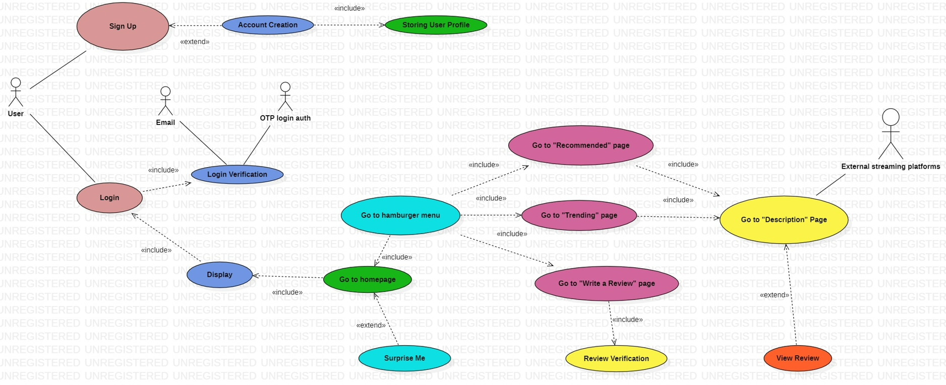

**Use Case Description 1**

| Use Case ID: | Case_1_GTH | | |
| --- | --- | --- | --- |
| Use Case Name: | Go to homepage | | |
| Created By: | Seah Jun Sheng | Last Updated By: | Seah Jun Sheng |
| Date Created: | 6/9/22 | Date Last Updated: | 26/10/22 |

| Actor: | User (Participating) |
| --- | --- |
| Description: | Brings user to the homepage from whichever page the user is on |
| Preconditions: |  |
| Postconditions: | Homepage is displayed |
| Priority: | 2 |
| Frequency of Use: | Whenever user wants to go back to homepage |
| Flow of Events: | 1. User selects the “Home” option 2. System displays the homepage |
| Alternative Flows: | NIL |
| Exceptions: | NIL |
| Includes: | NIL |
| Special Requirements: | NIL |
| Assumptions: | NIL |

**Use Case Description 2**

| Use Case ID: | Case_2_GTRP1 | | |
| --- | --- | --- | --- |
| Use Case Name: | Get a Recommendation | | |
| Created By: | Seah Jun Sheng | Last Updated By: | Seah Jun Sheng |
| Date Created: | 6/9/22 | Date Last Updated: | 26/10/22 |

| Actor: | User (Participating) |
| --- | --- |
| Description: | Recommends user animes depending on which anime the user is currently interested in |
| Preconditions: | - |
| Postconditions: | “Recommended” subpage is displayed |
| Priority: | 2 |
| Frequency of Use: | Whenever the user wants to go to the “recommended” subpage |
| Flow of Events: | 1. User clicks “browse” or “search” icon 2. System will show the user a list of animes (search page) 3. User clicks on an anime card he is interested in 4. System will show “more info” and “related” depending on the anime poster clicked 5. User clicks on “related” 6. “Recommended” subpage is displayed |
| Alternative Flows: | Nil |
| Exceptions: | Nil |
| Includes: | NIL |
| Special Requirements: | Nil |
| Assumptions: | Nil |

**Use Case Description 3**

| Use Case ID: | Case_3_GTTP | | |
| --- | --- | --- | --- |
| Use Case Name: | Go to “Trending” Page | | |
| Created By: | Loke Kah Hou | Last Updated By: | Seah Jun Sheng |
| Date Created: | 6/9/2022 | Date Last Updated: | 26/10/2022 |

| Actor: | User (Participating) |
| --- | --- |
| Description: | Brings User to the “Trending” page |
| Preconditions: | - |
| Postconditions: | “Trending” page is displayed by the System |
| Priority: | 2 |
| Frequency of Use: | When the User decides to go to the “Trending” page |
| Flow of Events: | 1. User clicks “browse” or “search” icon 2. System will display the search page 3. User clicks on filter icon 4. User clicks on “Trending” 5. System displays “Trending” page consisting of all the anime cards of those which are trending |
| Alternative Flows: | NIL |
| Exceptions: | NIL |
| Includes: | NIL |
| Special Requirements: | NIL |
| Assumptions: | NIL |

**Use Case Description 4**

| Use Case ID: | Case_4_SM | | |
| --- | --- | --- | --- |
| Use Case Name: | Surprise Me | | |
| Created By: | Bhat Sachin | Last Updated By: | Seah Jun Sheng |
| Date Created: | 8/9/2022 | Date Last Updated: | 26/10/2022 |

| Actor: | User (participating, receiving) |
| --- | --- |
| Description: | Surprises the user with a random anime title. |
| Preconditions: | NIL |
| Postconditions: | The user is shown a random anime title. |
| Priority: | 3 |
| Frequency of Use: | When the user wants a surprise title. |
| Flow of Events: | 1. The user is on the homepage currently. 2. The user clicks on “Surprise Me!” 3. System will ask the user questions about his anime preference and other history 4. System will direct user to a description page of a random anime depending on the answers given to (3) |
| Alternative Flows: | NIL |
| Exceptions: | NIL |
| Includes: | NIL |
| Special Requirements: | NIL |
| Assumptions: | NIL |

**Use Case Description 5**

| Use Case ID: | Case_5_GTDP | | |
| --- | --- | --- | --- |
| Use Case Name: | Go to Description Page | | |
| Created By: | Bhat Sachin | Last Updated By: | Seah Jun Sheng |
| Date Created: | 8/9/2022 | Date Last Updated: | 26/10/2022 |

| Actor: | User (participating, receiving) |
| --- | --- |
| Description: | Go to the description page of an anime. |
| Preconditions: | nil |
| Postconditions: | The user is directed to the description page of an anime. |
| Priority: | 3 |
| Frequency of Use: | Whenever the user wants to find out more about an anime |
| Flow of Events: | 1. In the homepage, user can click on an anime poster he is interested in 2. System will display the description page of the anime the user clicked on |
| Alternative Flows: | 1. In the search page, trending page, or recommended page, user can click on an anime card he is interested in 2. System will show “more info” and “related” depending on the anime poster clicked 3. User clicks on “more info” 4. System will display the description page of the anime the user clicked on |
| Exceptions: | NIL |
| Includes: | NIL |
| Special Requirements: | NIL |
| Assumptions: | NIL |